Toronto Metropolitan University

Lab Report 3:

Semiconductor Diodes

Cheng, Vincent 501173673
Mourad, Shai 501170415
PCS 224 Section 09/14
Professor X. Yuan
T.A Revin Toquero
31 October, 2023

Introduction
The main goal of this experiment is to understand the behavior of diodes, their current-voltage relationship, and to experimentally determine Boltzmann’s constant. Diodes function as electrical valves, facilitating current flow in a single direction and preventing it in the opposite direction. By linking diodes to various voltage sources and observing their current-voltage correlations, we aim to enrich our grasp of the principles of semiconductor materials. This lab uses a n-p-n transistor to evaluate diode properties and to demonstrate their unidirectional current conduction. We'll carry out numerous measurements during the lab, capturing data points like base voltage and collector current across three different temperature conditions.

Theory
Diodes facilitate current flow in a singular direction and impede it in the opposite. The flow of current, when a diode is attached to a voltage source, depends on the polarity of the voltage.A forward-biased diode allows current to flow due to the positive voltage applied to its anode (relative to its cathode), whereas a reverse-biased diode blocks current flow due to the negative voltage applied to its anode. The relationship between current $I$ passing through the device and voltage $V$ across the junction is encapsulated in this equation:
$I=I_{o}(exp(\frac{V}{V_{t}})-1)$
Equation (1)

The term $I_{0}$ defines the reverse saturation current which is the small amount of current that flows through the diode when it is reverse-biased. $V_{t}$, or the "thermal voltage," is represented by:
$V_{t}=\frac{K_{B}T}{q}$
Equation (2)

$K_{B}$ symbolizes Boltzmann's constant ($1.38×10^{-23}J/K$), T denotes the temperature, and q signifies the charge carrier’s charge. When distinguishing biases, in a forward bias, both the applied voltage V and the current are positive. However, in a reverse bias, both V and the current adopt negative values, indicating a reversal in current direction.
When people are speaking informally, they describe diodes as not allowing any current to flow when reverse-biased is a simplification that emphasizes their primary behavior, which is to significantly impede the flow of current in the reverse direction. The reverse saturation current $I_{0}$ is small enough to be negligible.

Procedure
The temperature sensor was connected to the LabQuest/Pro, and Graphical analysis was opened. A live temperature readout was observed in the bottom right corner of the screen. The emitter and the base of the n-p-n transistor were connected to the multimeter, the multimeter was turned on, and it was set to the “diode” setting. Given that the diode setting applied a voltage of 1.5V, this caused a forward bias current for the diode under test, and the reading was noted on the meter. The leads on the meter were reversed, and the reading was noted again. The previous two steps were repeated for the collector and base leads, confirming that the transistor comprises diodes that conduct current in only one direction. The transistor, meter(s), and power supply were connected as per the circuit diagram shown in (Fig. 3). On the device, letters for “B” (Base), “E” (emitter), and “C” (collector) were identified. As depicted in the diagram, the base (yellow wire) was ensured to be connected directly to the collector (red wire). Measurements of the collector current and base voltage were taken, starting from a small current value and incrementing up to 200mA. Successive values of current and voltage were noted, doubling the current each time until 200 mA was reached, ensuring not to exceed the 200mA limit of the power supplies. The room temperature, which served as an approximation for the transistor's temperature, was recorded. Data was collected for at least 60 seconds before stopping. The mean temperature value and its associated uncertainty were recorded. Step (6) was repeated with the transistor immersed in an ice-water mixture, and the temperature of this mixture was recorded with the probe submerged in the water. Step (6) was repeated with the transistor placed in hot tap water, and the temperature of this water was recorded with the probe submerged. The circuit was dismantled, and any water used was returned to the kettles/cooler.
Using the natural logarithm of the current and the voltage, a data plot was created. The plot included three linear graphs and a mx+b equation for each temperature. By deriving the fundamental equations and relating them with the mx + b equation, K_{B} and I₀ were calculated along with their standard deviations. The K_{B} and I₀ values were then compared to the actual values, and a V value was calculated to determine if the conceptual ideas behind the experiment held true.

Apparatus
- Silicon bipolar junction transistor (n-p-n, TIP41A)
- Dual multimeter box
- 200mA current supply
- Temperature Probe
- Vernier LabQuest Mini or LabPro
- Insulated cup
- Ice cubes
- Hot water (∼ $50°C$)

Results and Data
 | Room Temperature (˚C) | Ice (˚C) | Hot (˚C)
Temperature | 23.890 | 1.035 | 66.292
Standard Deviation | 0.133 | 0.120 | 0.700
Table 1: Temperature readings of water at different temperatures using LabPro

Current (mA)  (± 0.05mA) | ln(Current) | Uncertainty of ln(Current)  = (0.05/Current) | Base Voltage (V) - Room Temperature (±0.0005V) | Base Voltage (V) - Ice (±0.0005V) | Base Voltage (V) - Hot  (±0.0005V)
2.0 | 0.6931471806 | 0.0250 | 0.521 | 0.578 | 0.399
4.0 | 1.386294361 | 0.0125 | 0.541 | 0.594 | 0.420
8.0 | 2.079441542 | 0.0063 | 0.562 | 0.613 | 0.442
16.0 | 2.772588722 | 0.0031 | 0.5840 | 0.630 | 0.467
32.0 | 3.465735903 | 0.0016 | 0.607 | 0.651 | 0.494
64.0 | 4.158883083 | 0.0008 | 0.633 | 0.672 | 0.524
128.0 | 4.852030264 | 0.0004 | 0.661 | 0.698 | 0.559
195.0 | 5.272999559 | 0.0003 | 0.679 | 0.715 | 0.582
Table 2: Comparing the Base Voltages of different Water Temperatures at a Current, the Natural Log of this Current, Along with Their Uncertainties.

 | Normal (Ω) (±0.05Ω) | Reversed (Ω) (±0.05Ω)
Emitter and Base | 487.0 | 1.0
Collector and Base | 484.0 | 1.0
Table 3: The Resistances of Different Lead Setups with the Multimeter

Analysis and Calculations

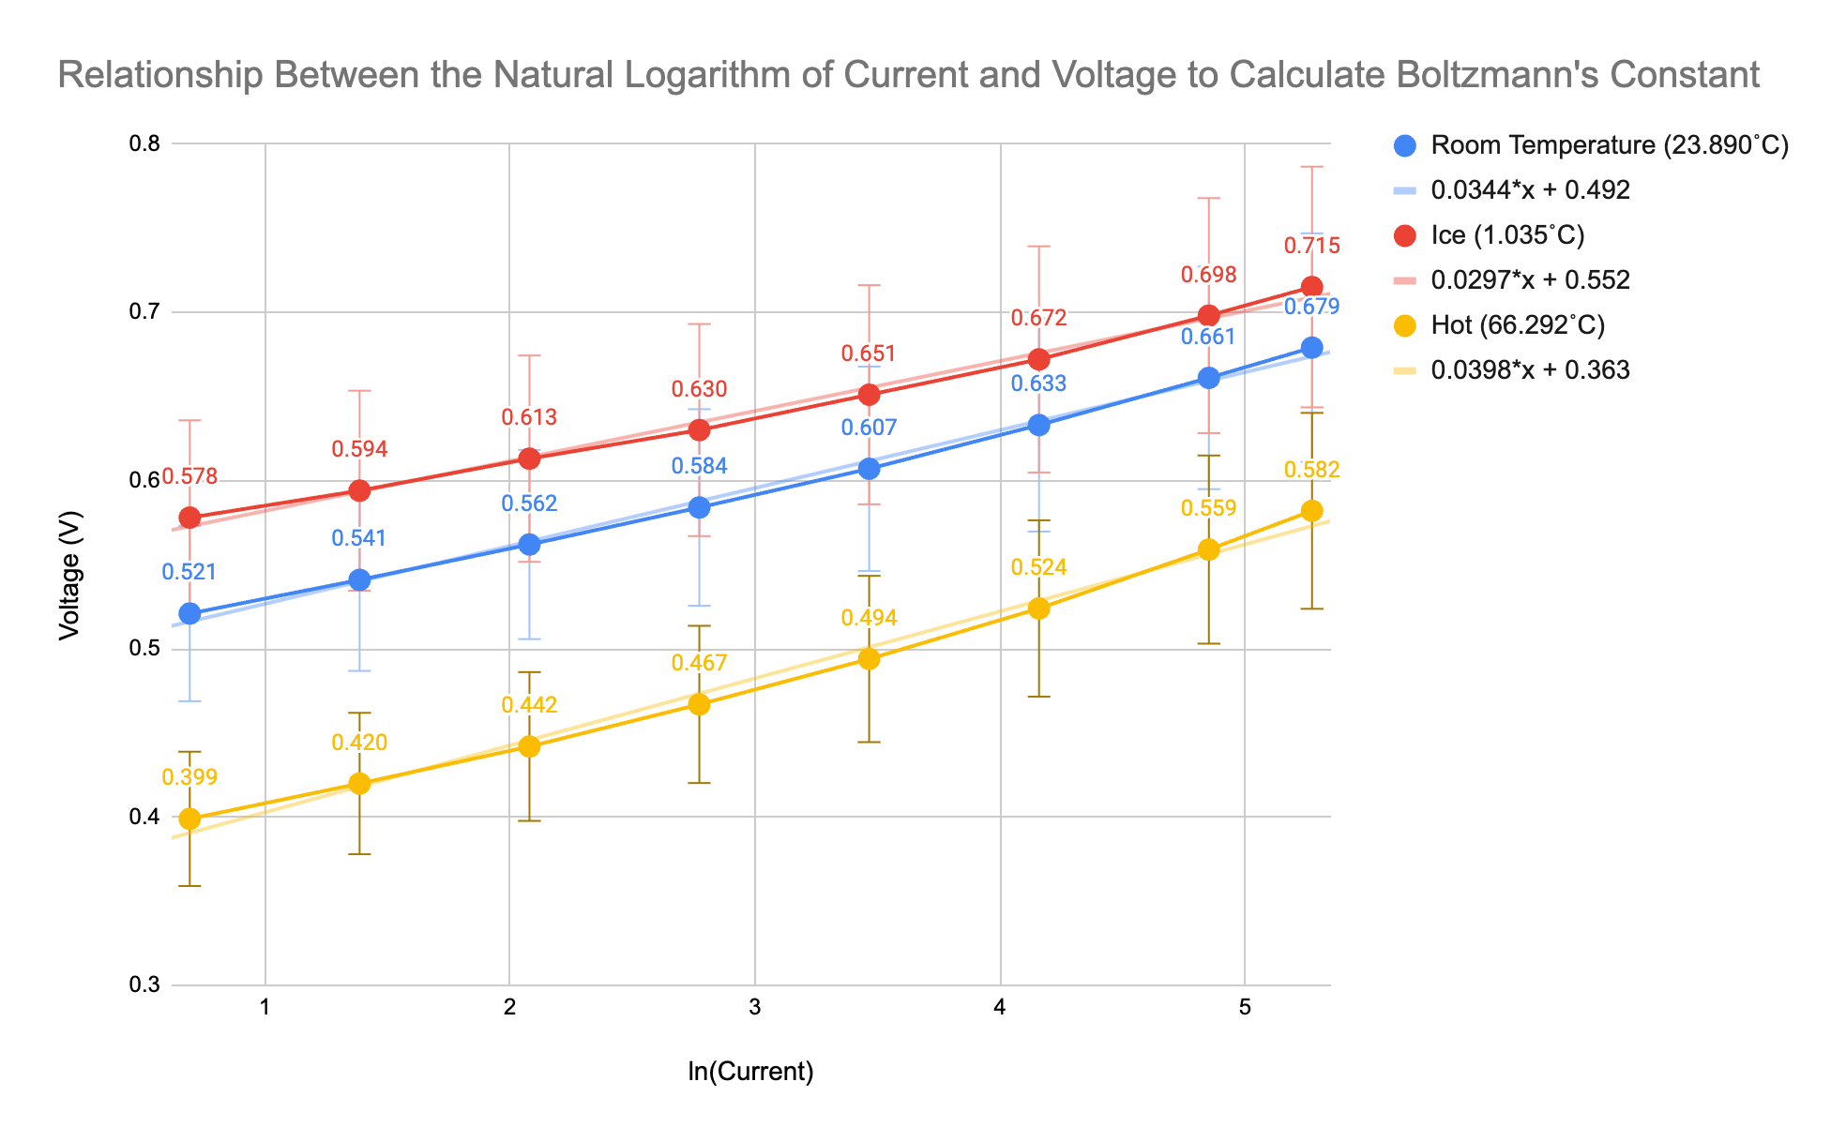
Figure 1: Graph of the Natural Log of the Current and the Voltage

Determining Boltzmann’s constant (K_{B})
$I = I_{0} exp[\frac{|q|V}{K_{B}T}]$
→ $ln(I) =ln(I_{0}) +[\frac{|q|V}{K_{B}T}]$
*ln(I₀) = y-int,
*$[\frac{|q|V}{K_{B}T}]$ = slope

From the Graph:
$ln(I) = \frac{q}{K_{B}T}$
→ $K_{B} = \frac{q}{ln(I_{0})T} = \frac{q}{slope*T}$
$K_{B}(Room Temperature) = \frac{1.6 x 10^{-19}C}{0.0344*(23..890˚C + 273 K)}$ = 1.57 x 10⁻²⁰ J/K

$K_{B}(Ice) = \frac{1.6 x 10^{-19}C}{0.0297*(1.035˚C + 273 K)}$ = 1.97 x 10⁻²⁰ J/K

$K_{B}(Hot) = \frac{1.6 x 10^{-19}C}{0.0398*(66.292 + 273 K)}$ = 1.18 x 10⁻²⁰ J/K

$I_{0} = e^{ln(I0)} = e^{y-int}$

$I_{0}(Room Temperature) = e^{0.492} =$1.64A

$I_{0}(Ice) = e^{0.552} =$ 1.74A

$I_{0}(Hot) = e^{0.363} =$1.44 A

Determining Standard Deviation
Standard Deviation of K_{B}:
*Mean = (Value1 + Value2 + Value3)/3

*Variance = [(Value1 - Mean)² + (Value2 - Mean)² + (Value3 - Mean)²]/3

Mean:
(1.57 x 10⁻²⁰ J/K + 1.97 x 10⁻²⁰ J/K + 1.18 x 10⁻²⁰ J/K)/3 = 1.57 x 10⁻²⁰ J/K

Variance:
[(1.57 x 10⁻²⁰ J/K - 1.57 x 10-20 J/K)² + (1.97 x 10⁻²⁰ J/K - 1.57 x 10-20 J/K)² + (1.18 x 10⁻²⁰ J/K - 1.57 x 10-20 J/K)²)/3 = 1.02 x 10⁻⁴¹ J/K

Square Root of Variance = Standard Deviation:

$\sqrt{1.02 x {10}^{-41} J/K}$ = 3.19 x 10⁻²¹ J/K

Standard Deviation of I₀:

Mean:
(1.64A + 1.74A + 1.44A)/3 = 1.60A
Variance:
[(1.64A - 1.60A)² + (1.74A - 1.60A)² + (1.44A - 1.60A)²]/3 = 1.54 x 10⁻² A

Square Root of Variance = Standard Deviation:

$\sqrt{1.54 x {10}^{-2}A}$ = 1.24 x 10⁻¹ A

 | K_{B} (J/K) (± 3.19 x 10⁻²¹ J/K) | I₀ (A) (± 1.24 x 10⁻¹ A)
Room Temperature | 1.57 x 10⁻²⁰ | 1.64
Ice | 1.97 x 10⁻²⁰ | 1.74
Hot | 1.18 x 10⁻²⁰ | 1.44
Table 4: The Calculated Values of I₀ and K_{B} With Their Standard Deviation

The accepted value of K_{B} is 1.38 x 10⁻²³ J/K:

Percent Error of Accepted and Calculated K_{B} Values:
Percent Error (Room Temperature) = $|\frac{(1.57 x {10}^{-20}J/K - 1.38 x {10}^{-23}J/K}{1.38 x {10}^{-23}J/K}| x 100\%$ = 113000%

Percent Error (Ice) = $|\frac{1.97 x {10}^{-20}J/K - 1.38 x {10}^{-23}J/K}{1.38 x {10}^{-23}J/K}| x 100\%$ = 142000%

Percent Error (Hot) = $|\frac{1.18 x {10}^{-20}J/K - 1.38 x {10}^{-23}J/K}{1.38 x {10}^{-23}J/K}| x 100\%$ = 86800%

The percent error of the calculated values are extraordinarily high. This may be a result of having inaccurate values when conducting the experiment. The actual K_{B} value is so incredibly small that in order to have a perfectly accurate calculated K_{B}, there must be extreme accuracy in the measurements within the lab. The obtained values of current, voltage, temperature, etc. all have a decimal place that is much higher than all of the results. The devices within the lab all round up to a certain decimal place. This increase or decrease will extremely affect the calculations since the answers are in the 10^{-20 to -30} range. Even a 0.0001 difference in value can change the results.

Discussion/Conclusion

Calculating V_{t}
$V_{t} = \frac{K_{B}T}{q}$
V_{t}(Room Temperature) = ($\frac{1.57 x {10}^{-20} J/K(23.890K + 273 K)}{1.6 x {10}^{-19}C})$
= 29.1 V

V_{t}(Ice) = ($\frac{1.97 x { 10}^{-20}J/K(1.035K + 273 K)}{1.6 x {10}^{-19}C})$
= 33.67 V

(
V_{t}(Hot) = ($\frac{1.18 x { 10}^{-20}J/K(66.292K + 273 K)}{1.6 x {10}^{-19}C})$
= 25.13 V

By comparing the obtained voltages within the lab to the calculated V_{t} values, V<<V_{t}, in all cases of temperature. This is a result of the inaccurate K_{B} values calculated.

If the forward Bias is fixed and the temperature is increased, the current will rise. When the temperature increases, the carrier and hole concentrations will increase. This will result in a higher current.

The objective of this lab is to use the current, voltage, and temperature collected from the lab experiment to calculate key values related to a diode. The results of this experiment are quite inaccurate to the actual values. For example at room temperature, the K_{B} had a 113000% error. It is theorized that this is a result of the experiments' inaccurate measurements. When a diode is in the forward bias position, the equation $I = I_{0} exp[\frac{|q|V}{K_{B}T}]$ holds true. From there, the equation was derived and the K_{B} and I₀ values were calculated. Since it is assumed that V>>V_{t} the exponential side of the equation must have the greatest effect on I. However, since the experiment’s data resulted in V_{t}>>V, I₀ is more dominant in the calculations. Within the “Graph of the Natural Log of the Current and the Voltage” it can be noted that the line for each temperature has the same properties, however their voltages are higher. This relationship is correct since within the wrap up it is mentioned that in a fixed forward bias, a higher temperature results in a higher voltage. Diodes are an extremely important aspect of electrical and computer engineering, since they are used within AC current; which is one of the fundamental aspects of the subspecialties. From the experiment, the behaviors of diodes at reverse and forward bias are true as a result of the observations taken within the experiment and calculations. For example when using the voltmeter, the raising of current resulted in a higher voltage. It can be learned from the calculations that it is extremely important to have accurate measurements of the data to have a proper comparison to the theoretical concepts.

References

Dr. Yuan Xu. 2023 Fall. Semiconductor Diode PCS224 [lab manual]. Toronto (ON): Toronto Metropolitan University

Serway, R. A., & Jewett, J. W. (2018). Physics for scientists and engineers (10th ed.). Cengage Learning.
Toronto Metropolitan University. (n.d.). Physics Lab Guide [PDF]. D2L. https://courses.torontomu.ca/d2l/le/content/795518/viewContent/5278918/View

